**Deploy applications on AWS EKS**

**1.** **Prerequisites** 2

**2.** **Setup infrastructure with Terraform** 2

**2.1. Set up AWS credential configure** 2

**2.2. Initialize the module** 2

**2.3. Verify the terraform plan** 4

**2.3.1. Verify Cluster using kubectl** 4

**2.3.2. Verify on AWS UI** 4

**3.** **Setup Jenkins server with Terraform** 7

**3.1. Initialize the module** 7

**3.2. Verify the terraform plan** 8

**3.3. Setup Jenkins account** 9

**4.** **Push images to AWS ACR** 10

**4.1. Add Webhook** 10

**4.2. Install plugins on Jenkins** 12

**4.3. Create IAM role** 12

**4.4. Setup Jenkins Global credentials** 14

**4.5. Setup Jenkins Pipeline** 15

**5.** **EKS Setup** 17

**5.1. Install and Configure Ingress Controller** 17

**5.2. Configure Jenkins** 18

**5.3. Setup Jenkins Pipeline** 18

**6.** **Monitoring with Prometheus and Grafana** 19

1. **Prerequisites**

* AWS account (IAM user)
* AWS CLI
* Terraform
* Docker
* Kubectl
* Eksctl
* Helm

1. **Setup infrastructure with Terraform**

**2.1. Set up AWS credential configure**

**-** Run the command to set up your AWS CLI: aws configure

**-** Enter the access key of your IAM account, if you already configured press enter.

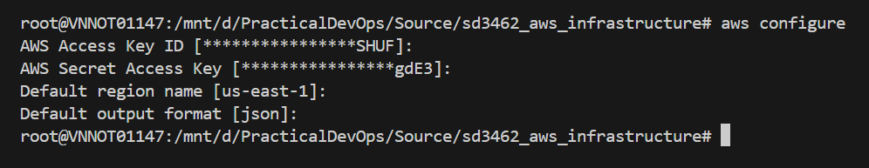

**2.2. Initialize the module**

**-** Move to the **“./eks-deploy/terraform”** directory to perform commands.

**-** Create the s3 bucket to store the *tfstate* file.

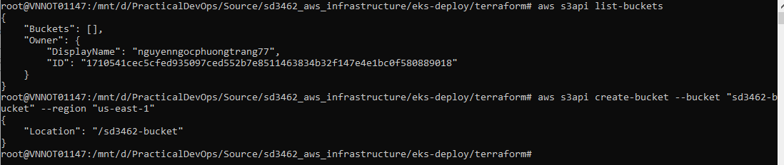

**-** Run the command terraform init -backend-config "key=${tfstate_file_name}" -backend-config "bucket=${tfstate_bucket_name}" -backend-config "region=us-east-1" to initializing the backend.

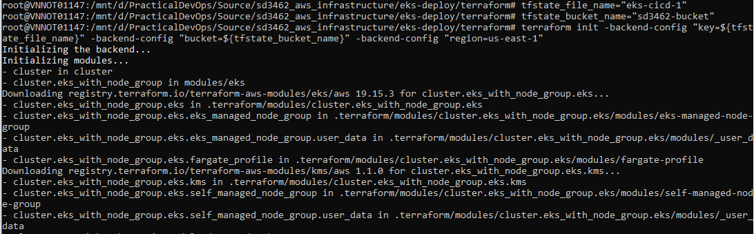

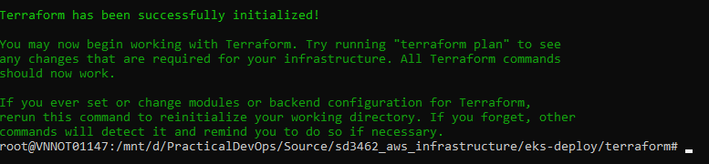

**-** After successfully initializing, run terraform validate to check whether the configuration is valid to ensure no issue when applying the terraform plan.



**-** Run terraform plan -var-file=”dev.tfvars” to apply the execution plan.

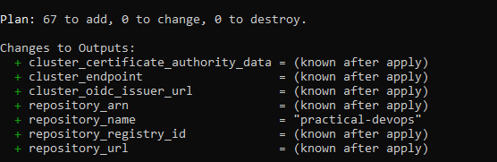

- Run terraform apply –var-file=”dev.tfvars” to create all the resource.

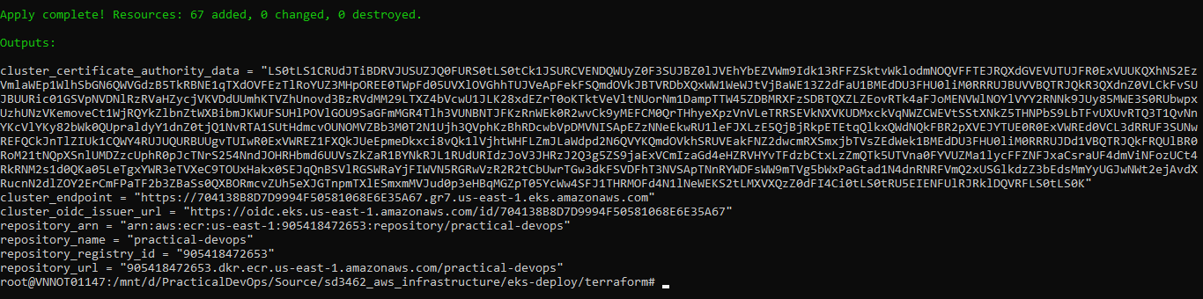

**2.3. Verify the terraform plan**

**2.3.1. Verify Cluster using kubectl**

- Check status of the Cluster aws eks --region us-east-1 describe-cluster --name devops-eks --query cluster.status.

- Configure kubectl with EKS API server credentials aws eks update-kubeconfig --region us-east-1 --name devops-eks.

- Check if you are pointing to the right kubernetes cluster kubectl config current-context



- Validate kubectl configuration master node.

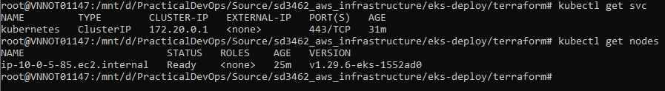

**2.3.2. Verify on AWS UI**

* S3 bucket.

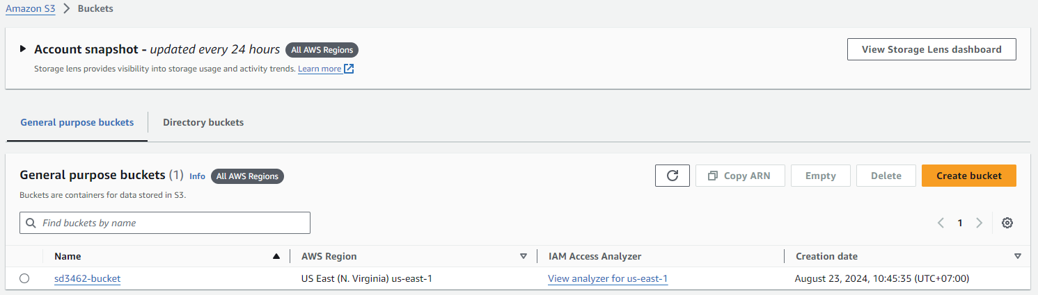

* Virtual private cloud.

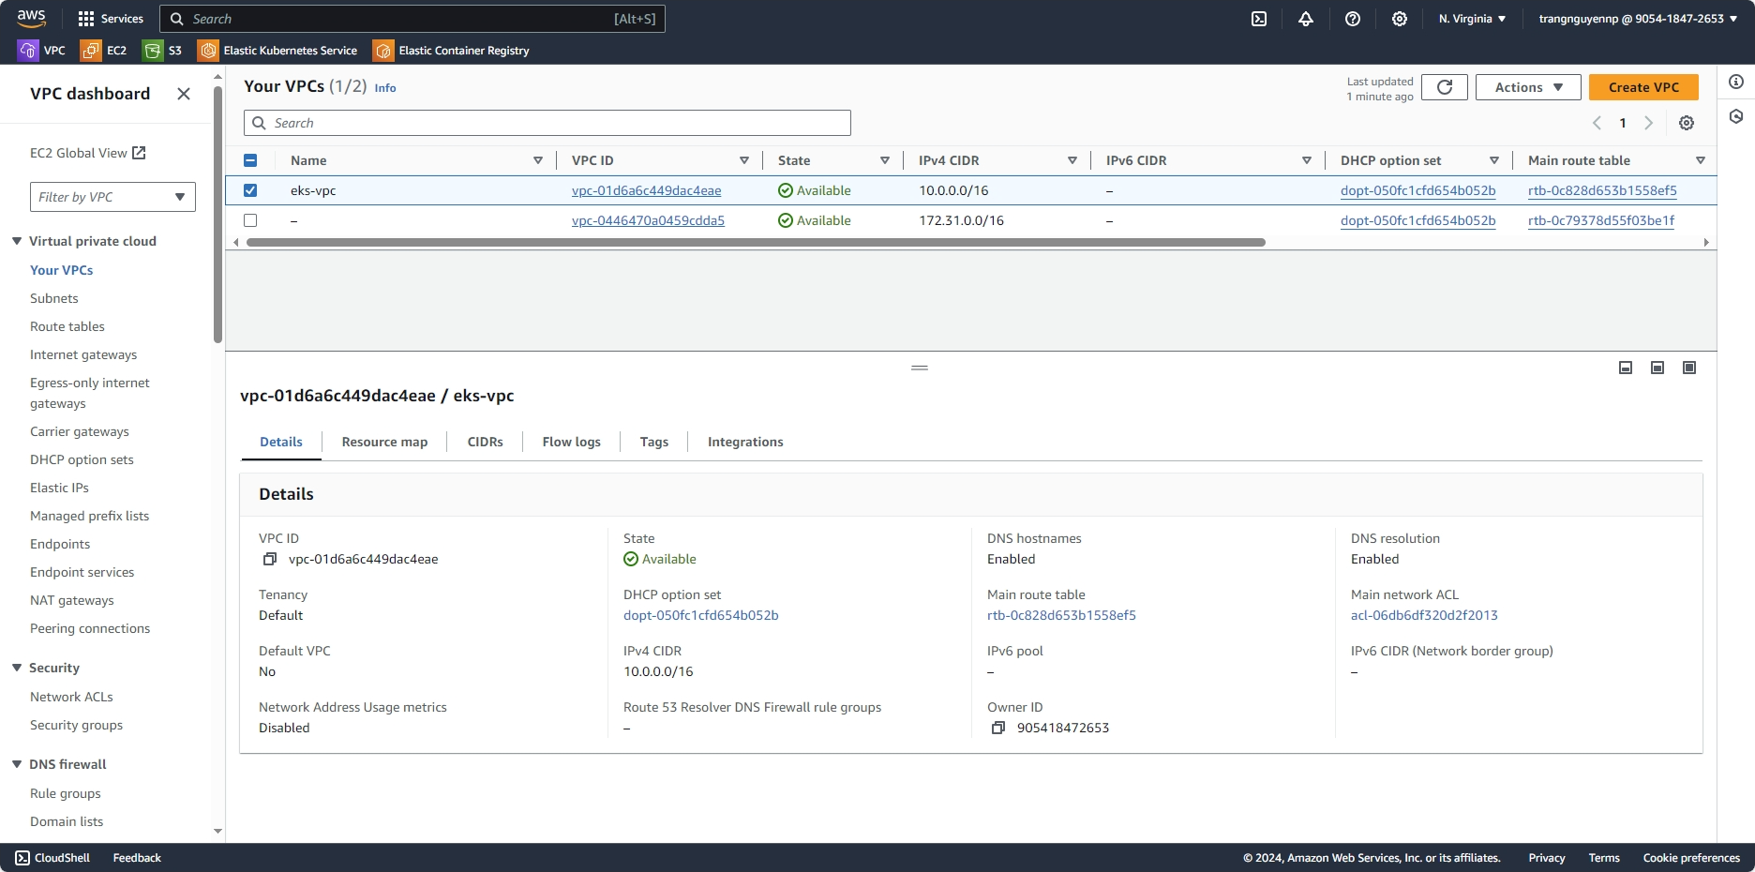

* EKS Cluster with OIDC Provider.

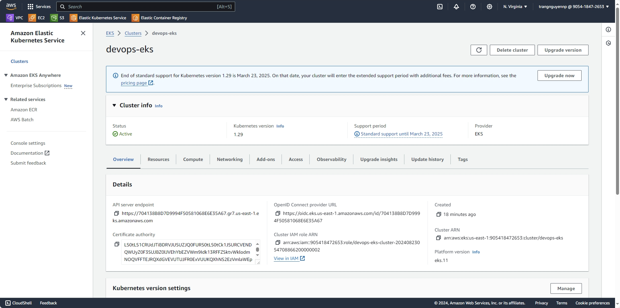

* EKS Managed AddOns.

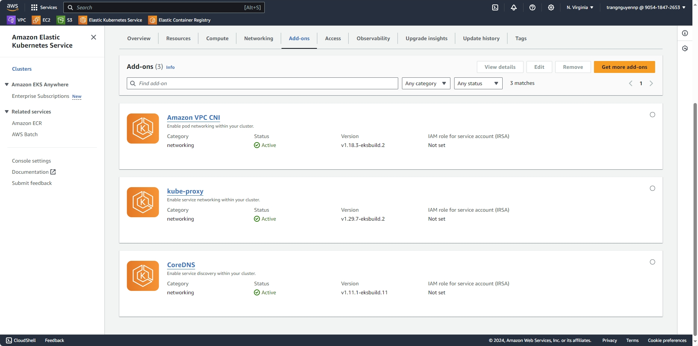

* EKS Managed node group.

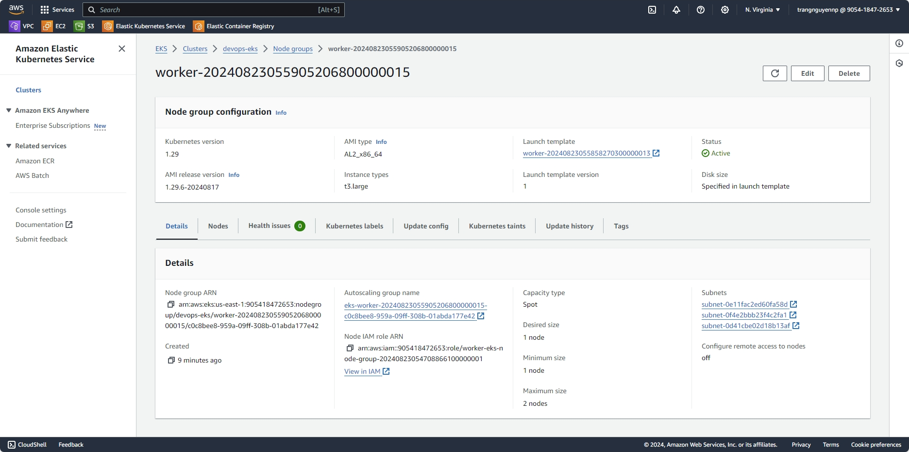

* EC2: worker nodes

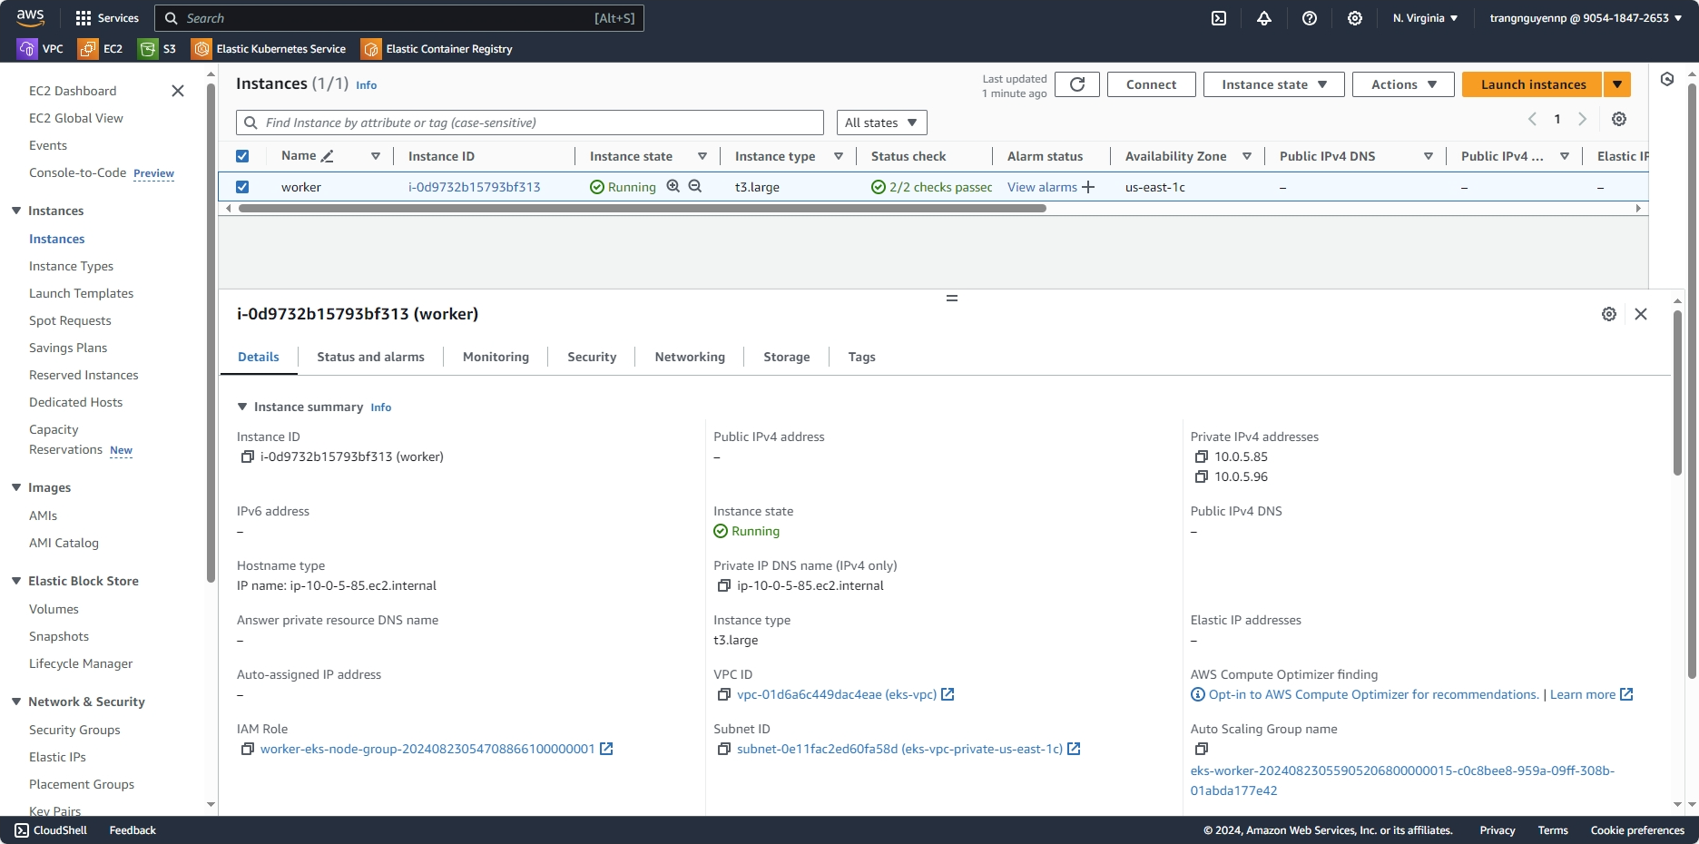

* ECR repositories

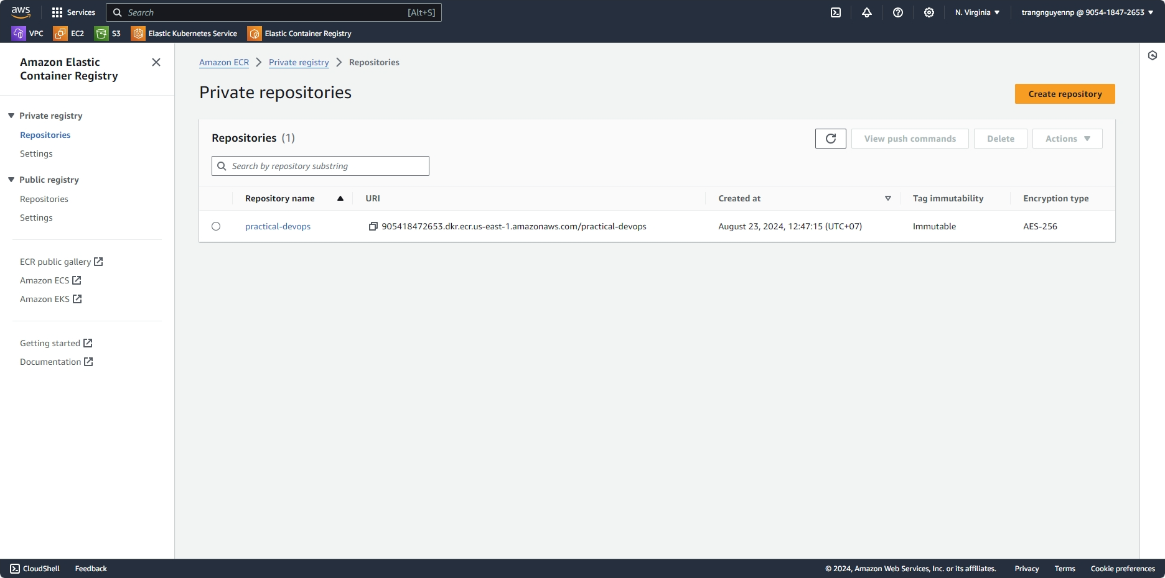

# **Setup Jenkins server with Terraform**

## **3.1. Initialize the module**

- Go to AWS UI page, create new key pair name **“jenkins-server-key”** in EC2 page.

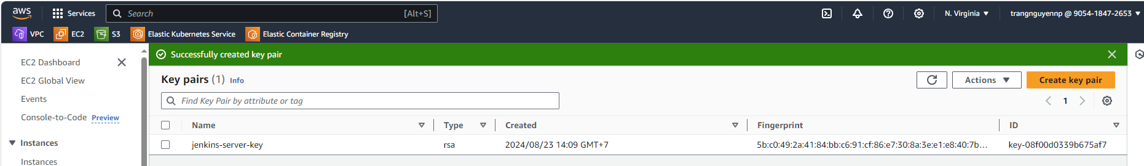

- Move to the **“./jenkins-server”** directory to perform commands.

- Run the command terraform init to initialize backend.

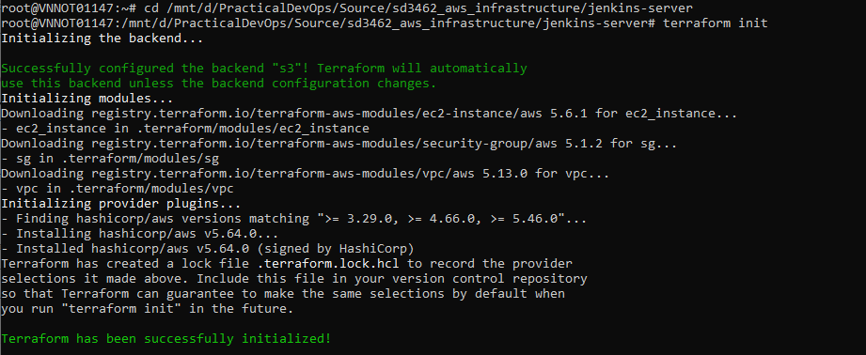

- After successfully initializing, run terraform validate to check whether the configuration is valid to ensure no issue when applying the terraform plan.

- Run terraform plan -var-file=”dev.tfvars” to apply the execution plan.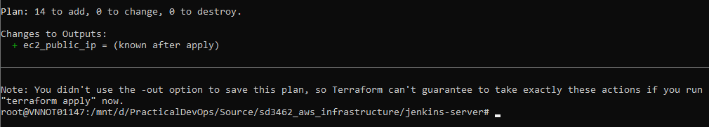

- Run terraform apply -var-file=”dev.tfvars” to create all the resource.

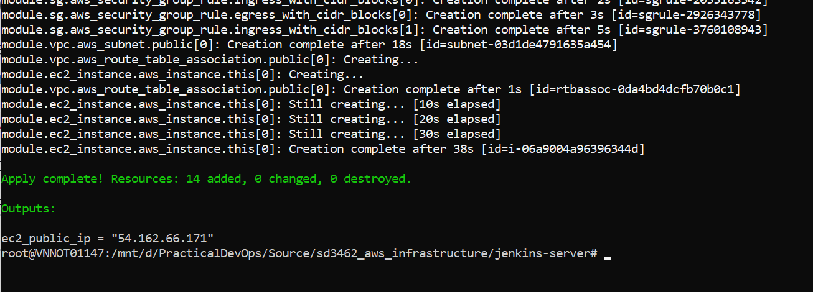

## **3.2. Verify the terraform plan**

- On EC2 page you will see the **jenkins-server** instance created.

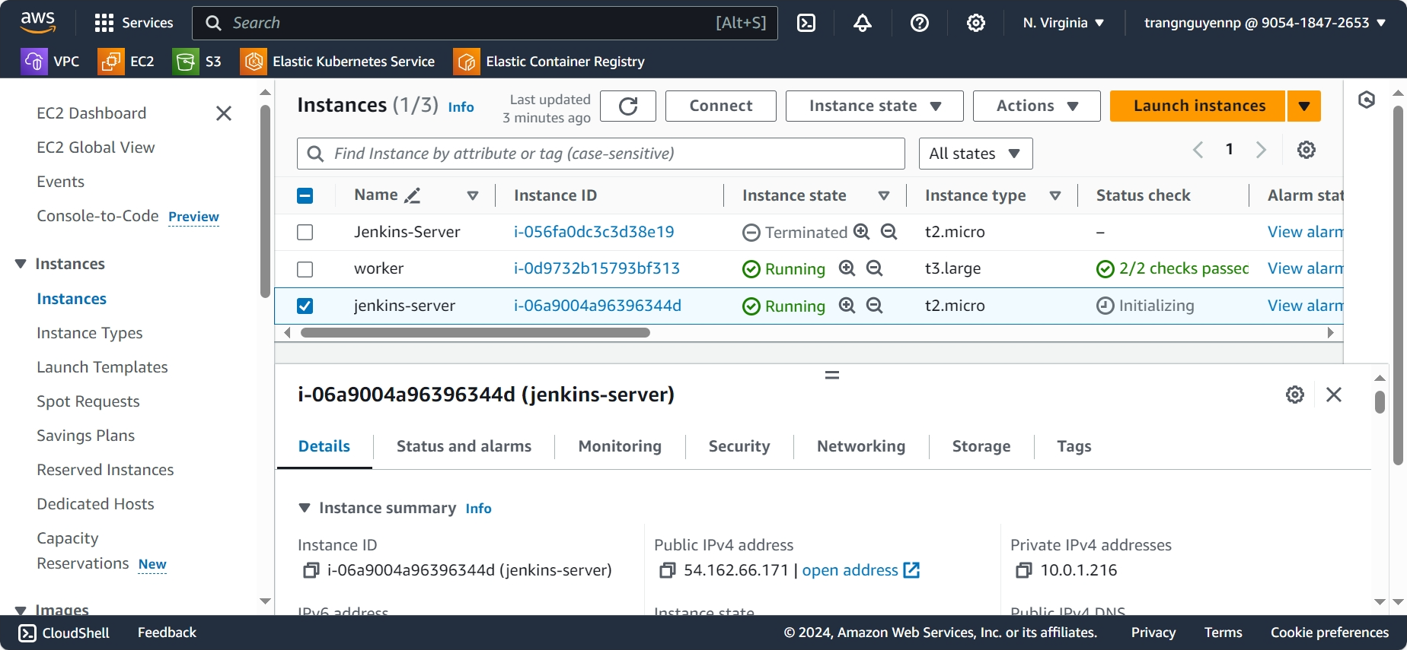

- Open address <http://ec2-public-ip:8080> to start the Jenkins.

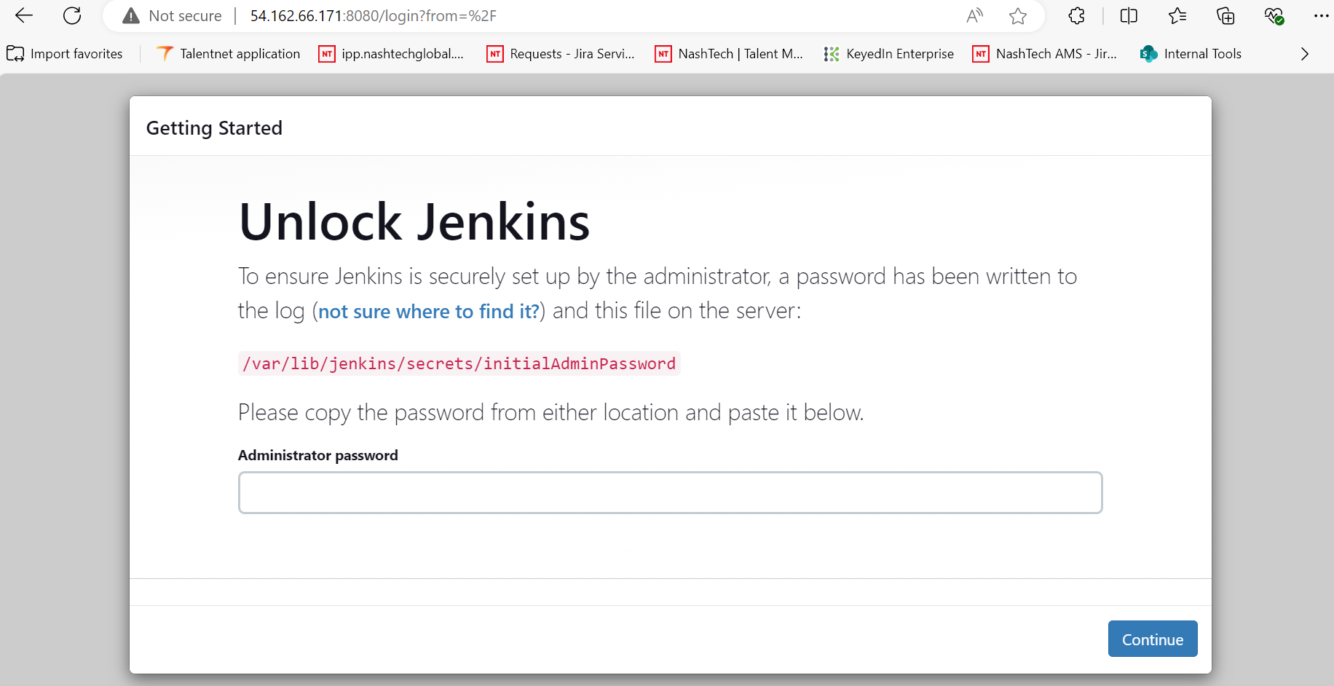

## **3.3. Setup Jenkins account**

- Following the getting started page to get the administrator password then setup your own username and password.

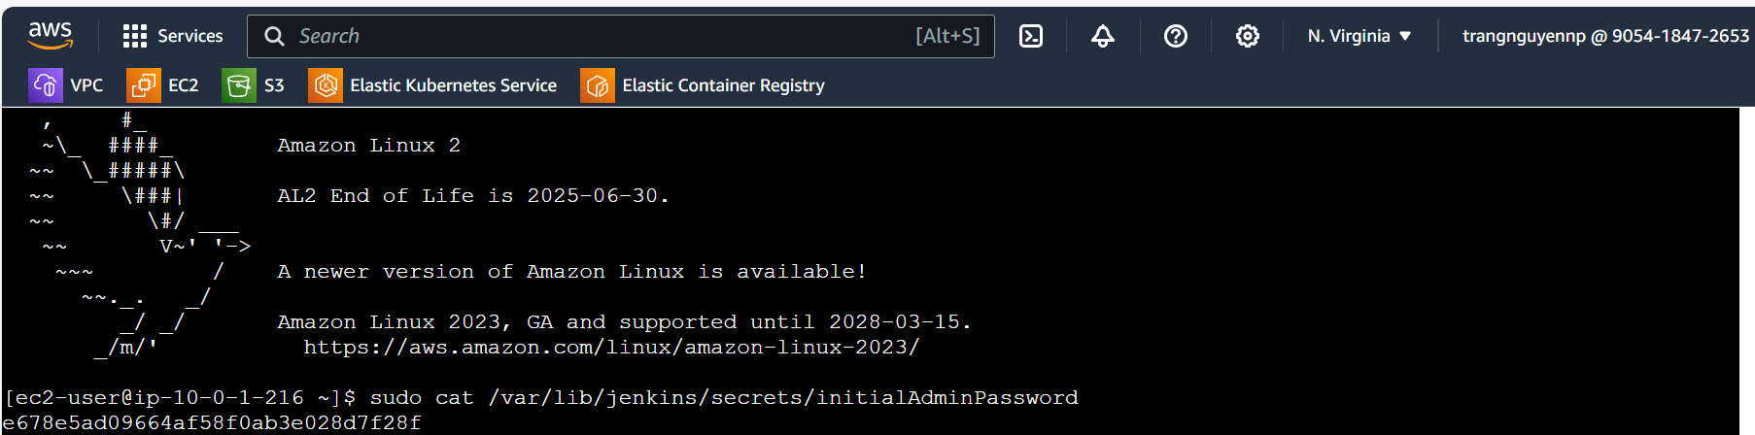

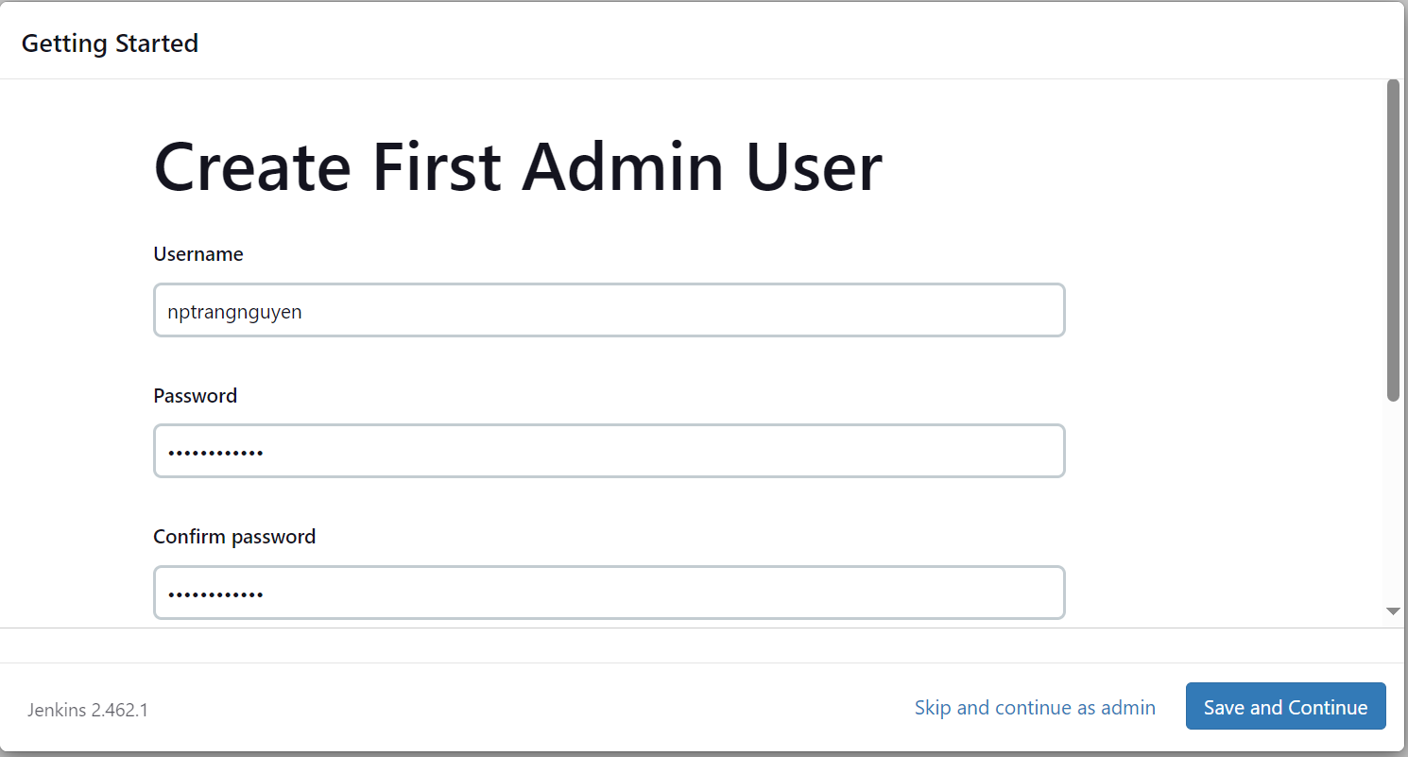

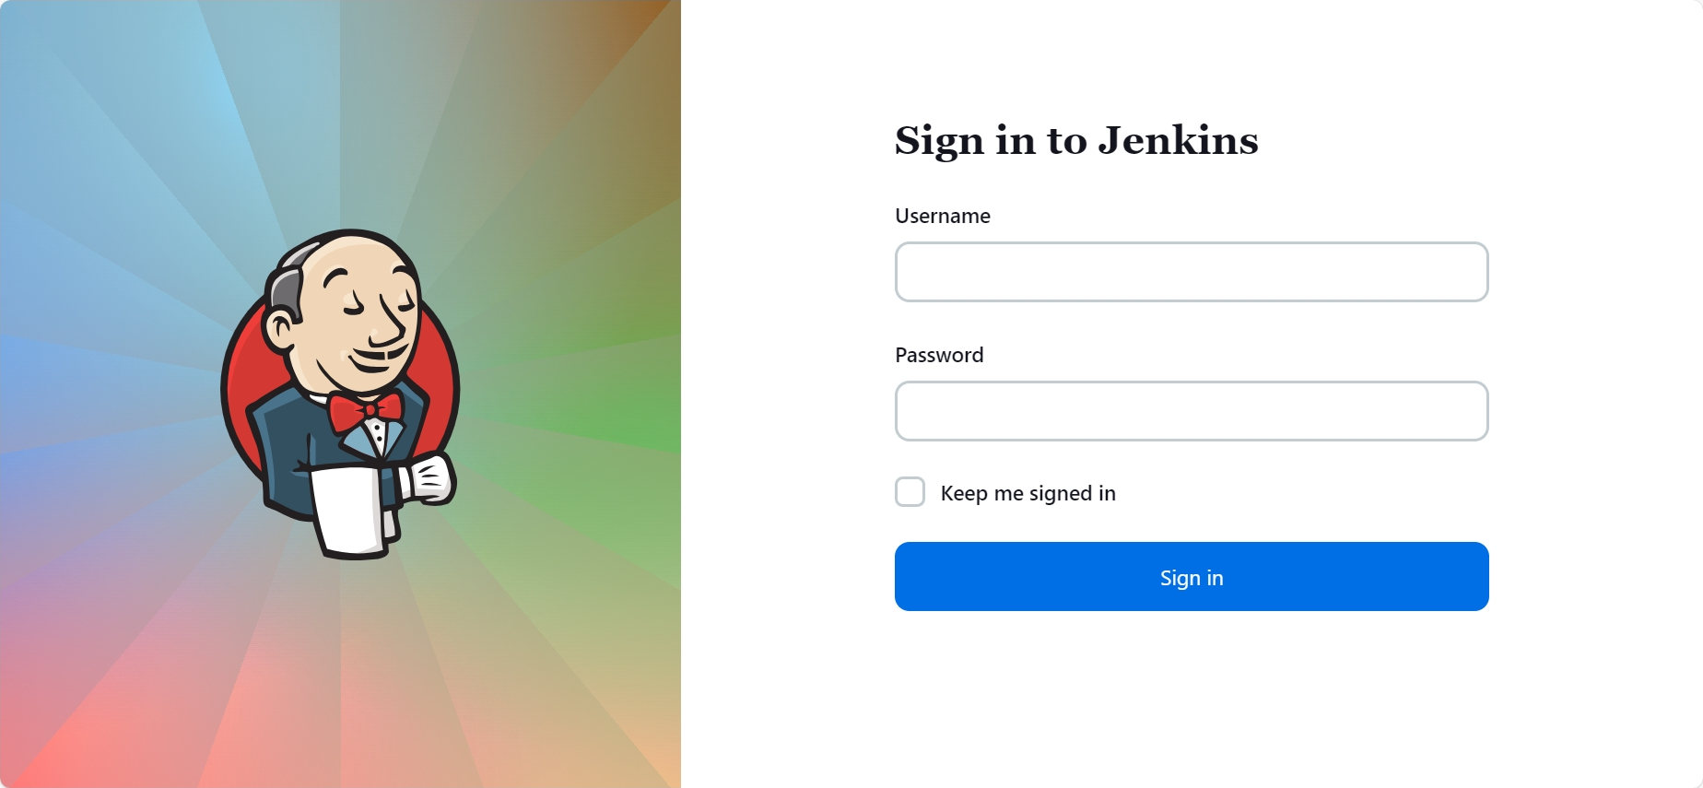

1. **Push images to AWS ACR**

## **4.1. Add Webhook**

* Add webhook for git repository. Click on **Repository settings** > **Webhook** and click **Add webhook.**

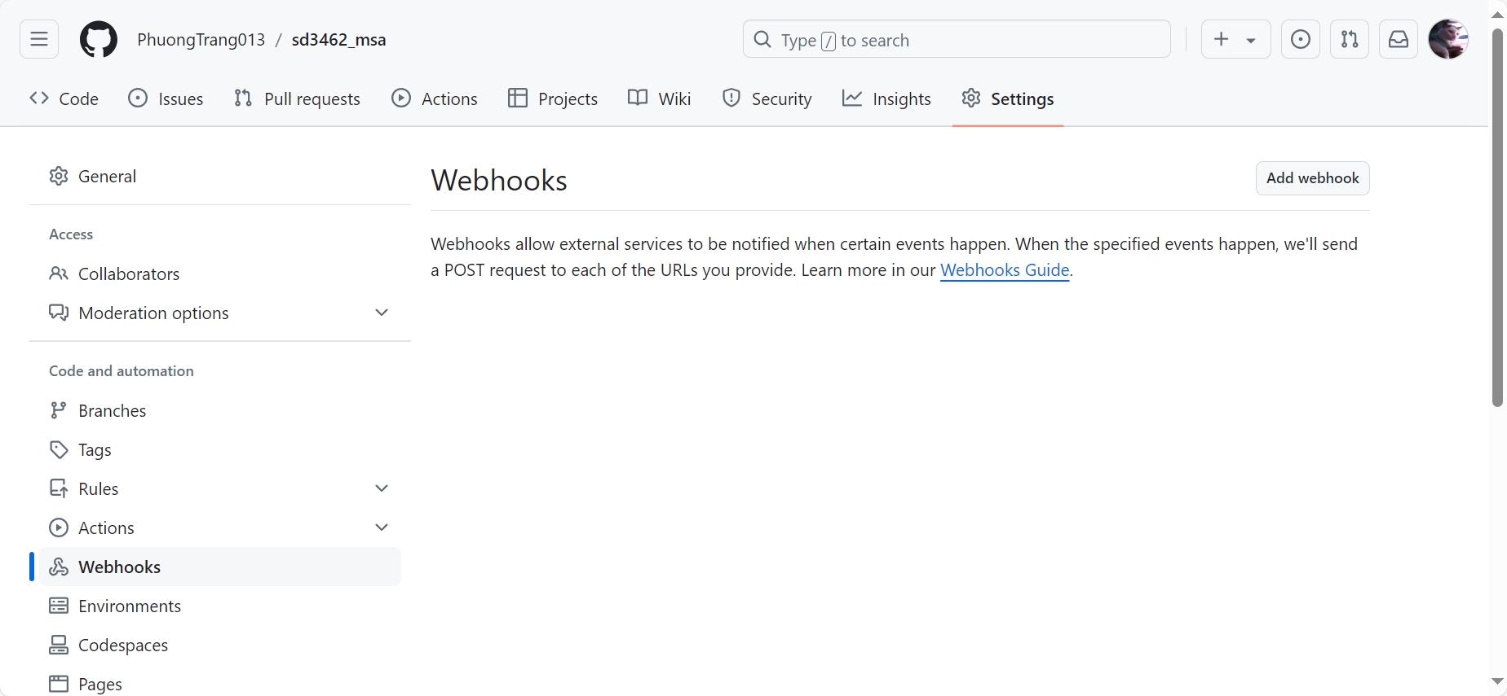

* Give a name to webhook > paste the url of the jenkins in the url section > click on generate secret > create webhook.

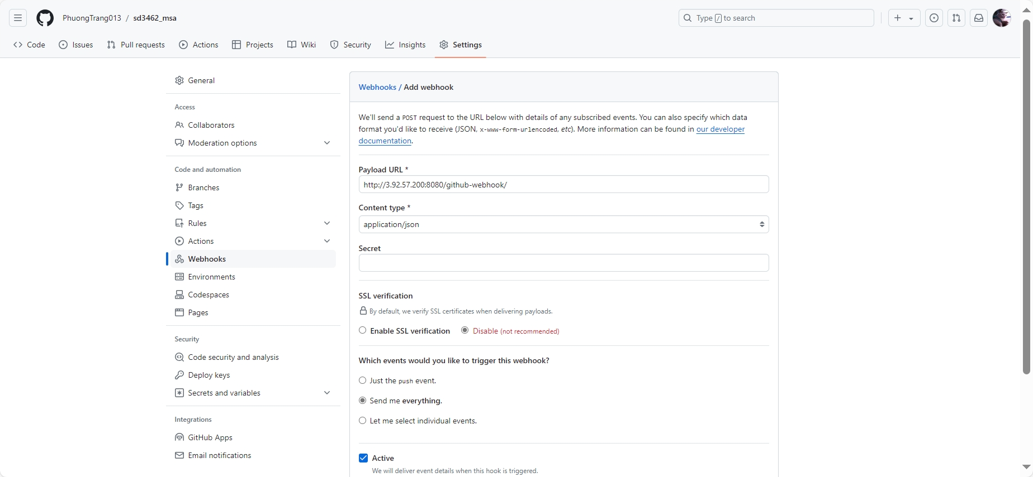

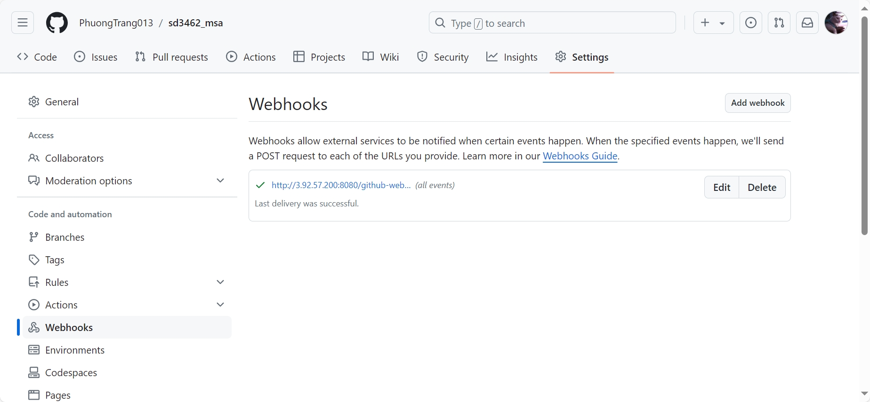

## **4.2. Install plugins on Jenkins**

* On Jenkins install necessary plugins to run docker and kubernetes commands.(docker, docker pipeline, amazon ecr )

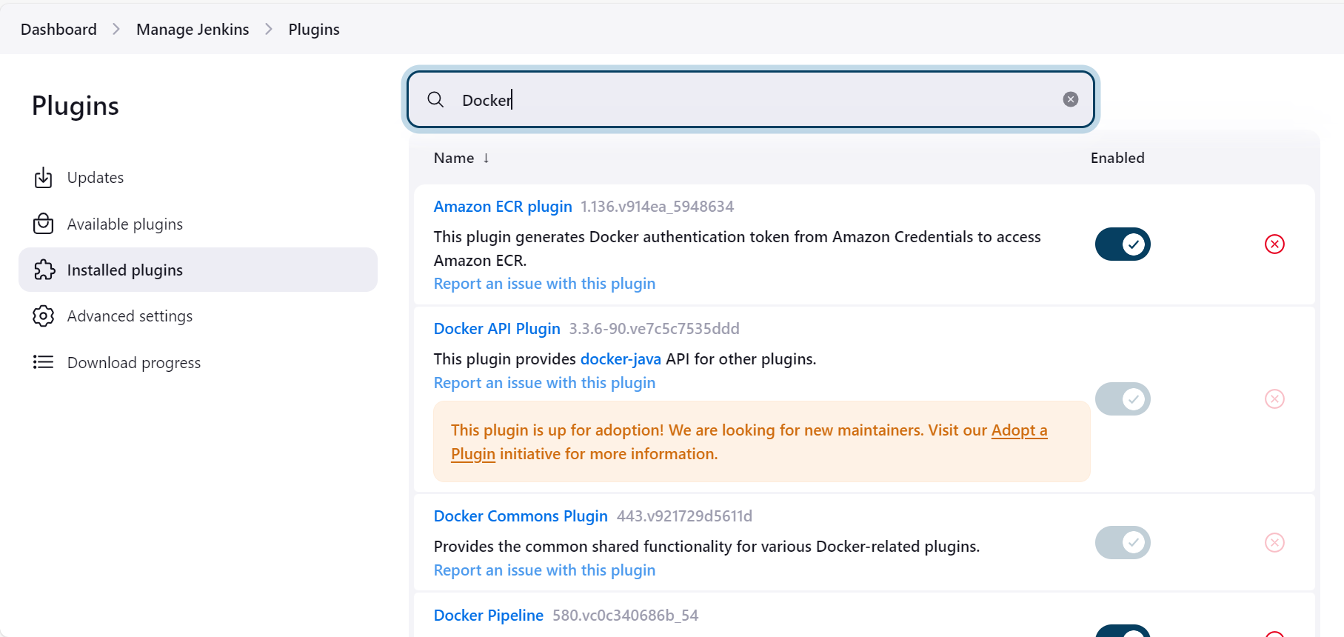

## **4.3. Create IAM role**

* Create IAM Role, go to **IAM** page and click **Create Role.** At select **trusted entity section**, choose **AWS service** for trusted type and **EC2** for the use case then click **Next**.

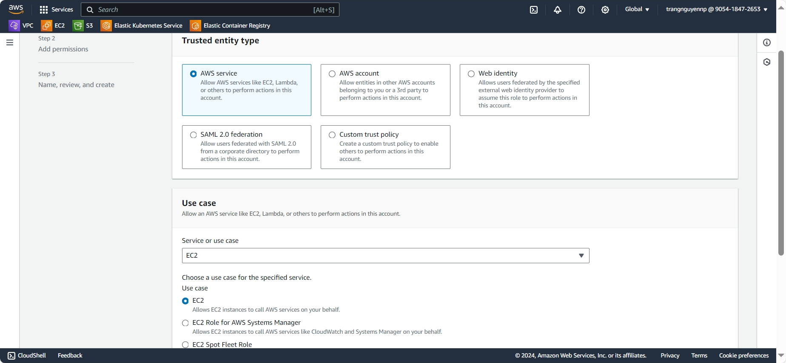

* On Add permissions section, add **AmazonEC2ContainerRegistryFullAccess** then click **Next**.

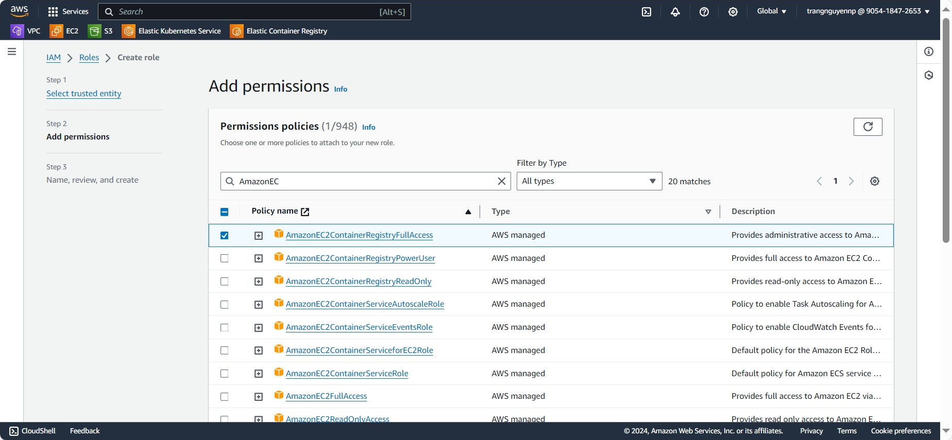

* Give a role name, review and click **Create role**.

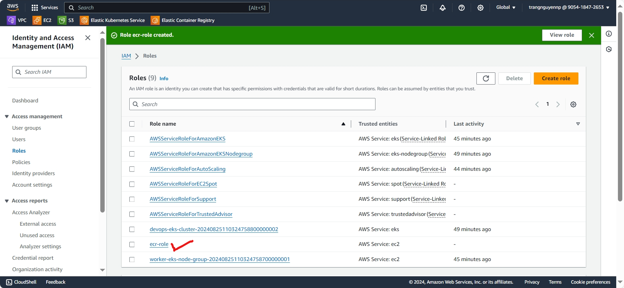

* Then add IAM role to “jenkins-server” on EC2 instances page.

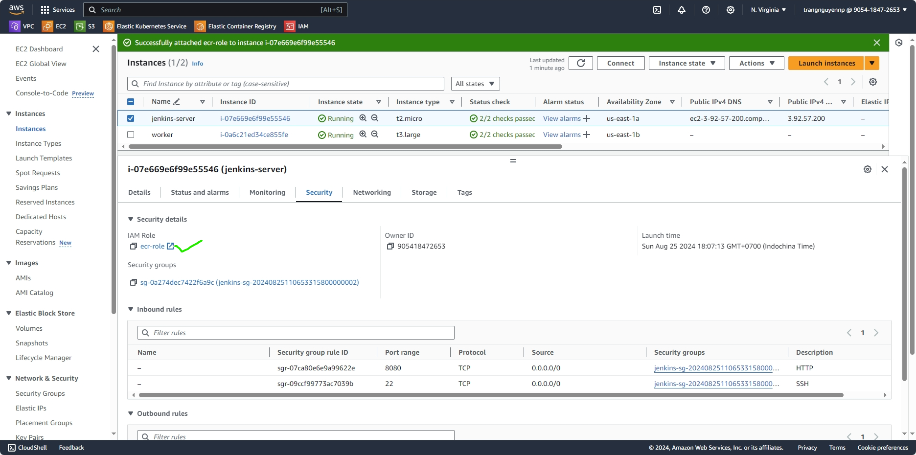

## **4.4. Setup Jenkins Global credentials**

* Add **AWS** **credential** and **Github credential** (personal access token), go to the Manage Jenkins>>Credentials>>system>>Global credentials.

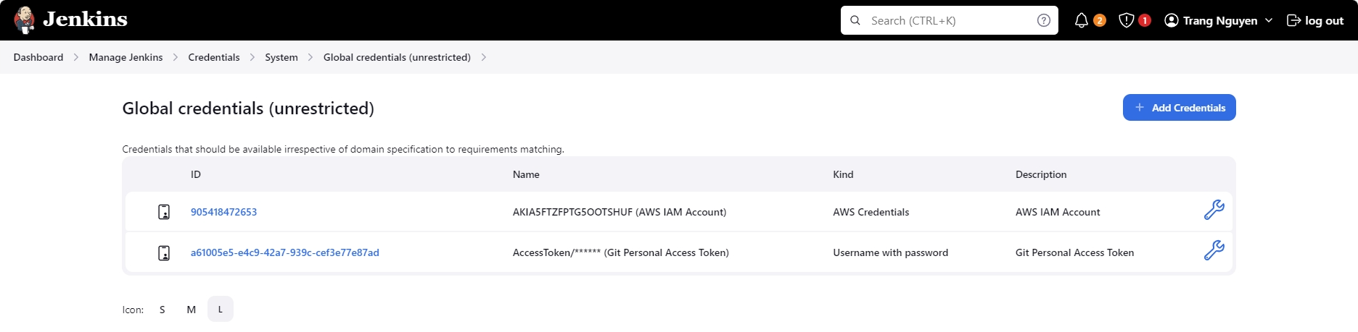

## **4.5. Setup Jenkins Pipeline**

* Create Jenkins pipeline, go to the Jenkins dashboard then click on “**New Item**” and choose “**Pipeline**” from the options.

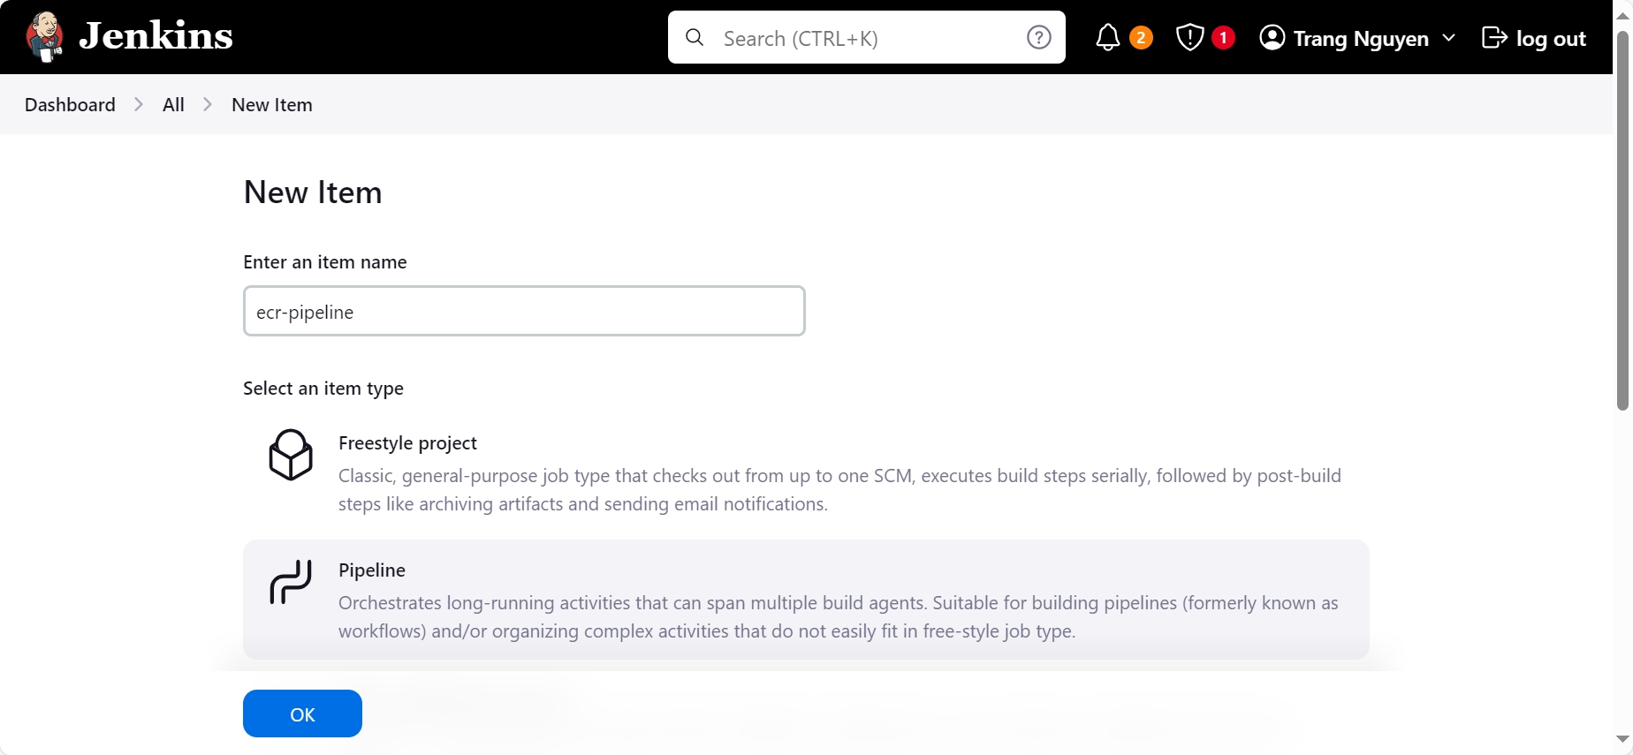

* Fill out the following fields for the pipeline, leaving everything else as default then **Save**.
* **GitHub hook trigger for GITScm polling** - check the box
* **Pipeline - Definition** - pipeline script from SCM
* **SCM** - Git
* **Repository URL** - the URL of your repo
* **Credentials** – github credential
* **Branch Specifier** - */main
* **Script path** – Jenkinsfile (the file stored in the MSA repository)

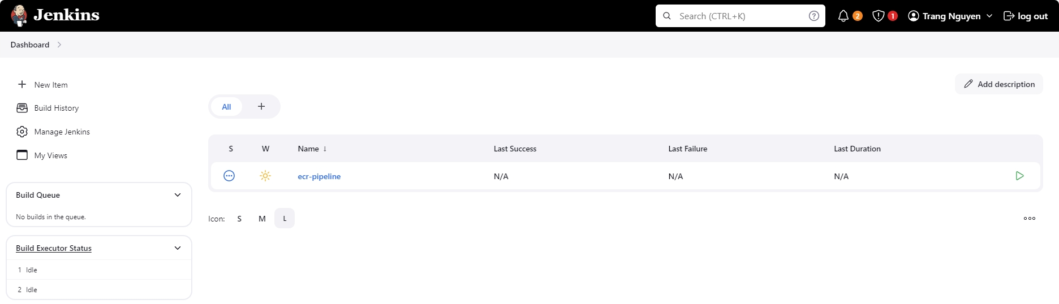

* When we commit on repo this will trigger a build on Jenkins.

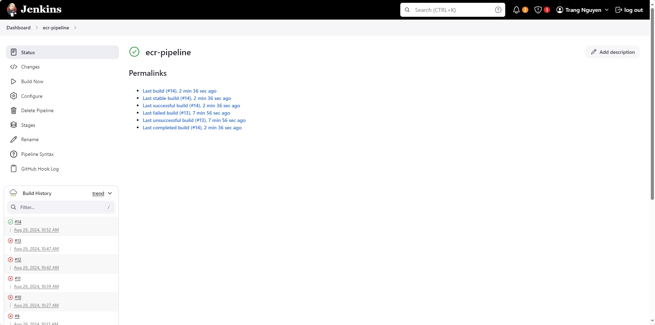

* Verify on AWS ECR page.

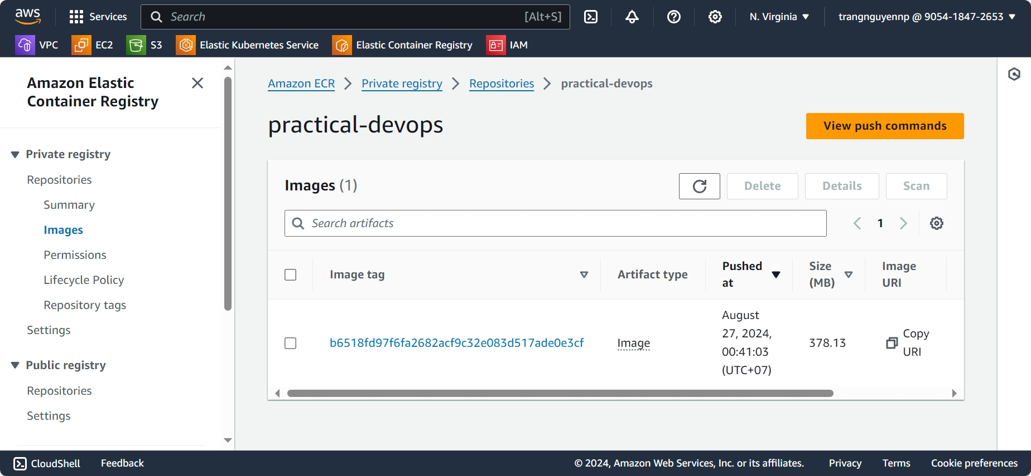

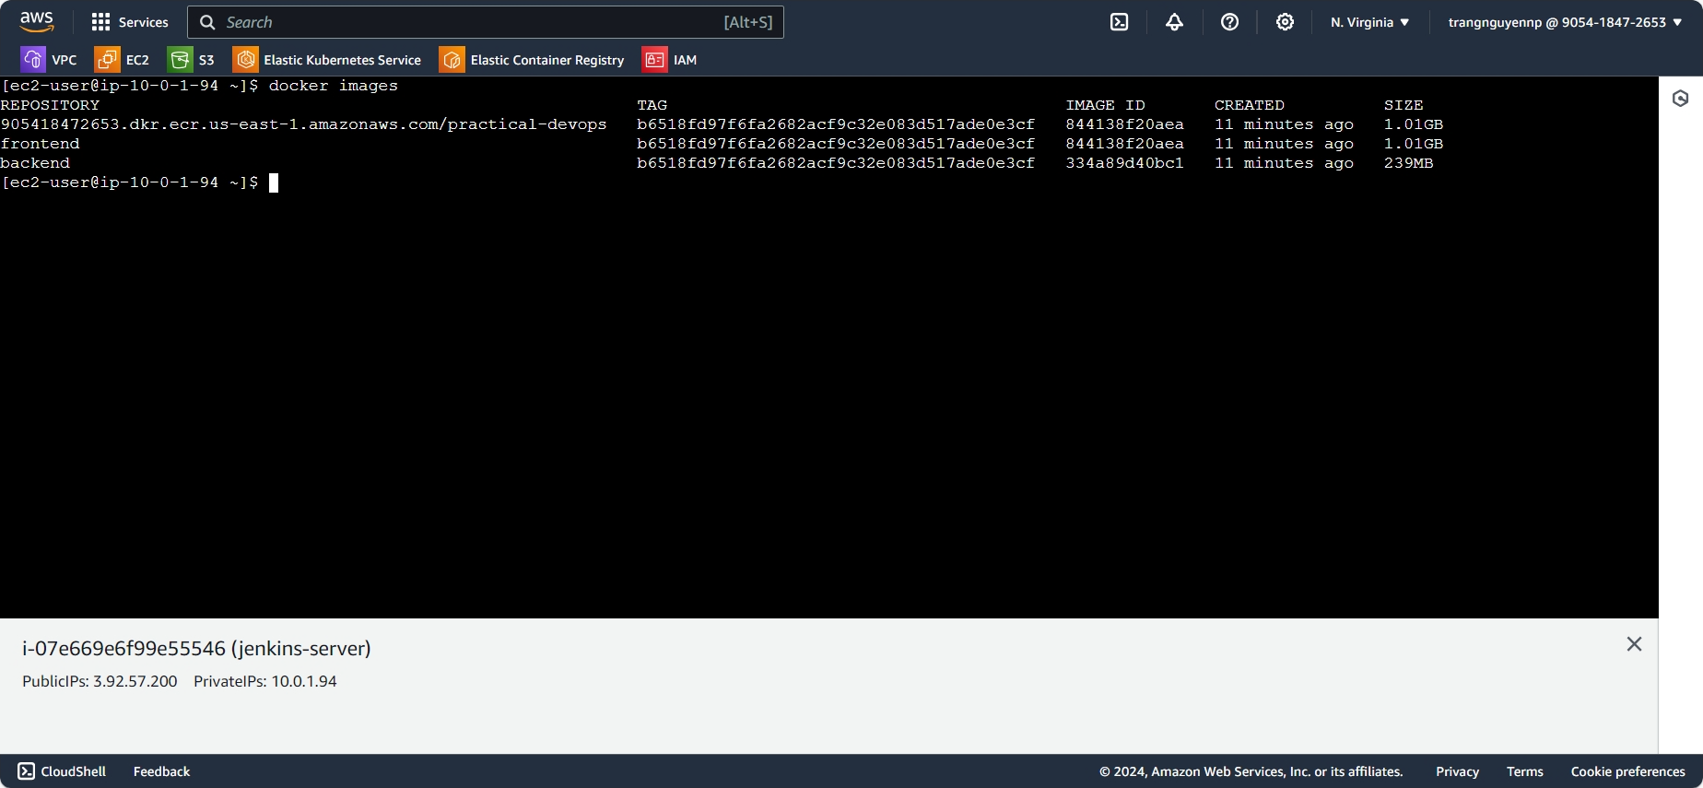

1. **EKS Setup**

## **5.1. Install and Configure Ingress Controller**

* Install the Nginx Ingress controller, use command:
  + kubectl apply -f https://raw.githubusercontent.com/kubernetes/ingress-nginx/controller-v1.7.1/deploy/static/provider/cloud/deploy.yaml
  + Verify: kubectl get pods --namespace=ingress-nginx | grep nginx
  + Verify: kubectl get services --namespace=ingress-nginx | grep nginx

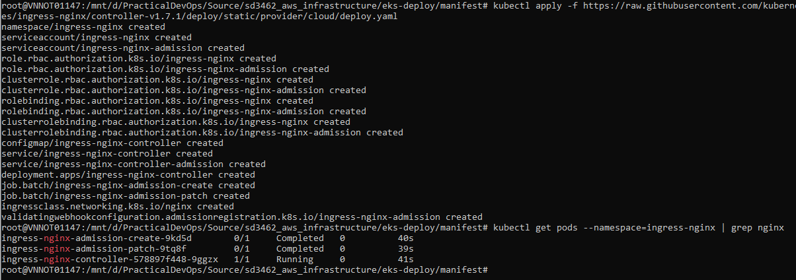

* Install application ingress: kubectl apply -f ingress.yml



* Verify application ingress: kubectl get ingress -o wide



## **5.2. Configure Jenkins**

* Add Kubernest Config Credentials, go to Manage Jenkins -> Manage Credentials.
  + Kind: Secret file
  + Scope: Global
  + File: config file
  + ID: kubeconfig-credentials-id
* To download kubeconfig file, use the following command: aws eks update-kubeconfig --region us-west-2 --name my-eks-cluster



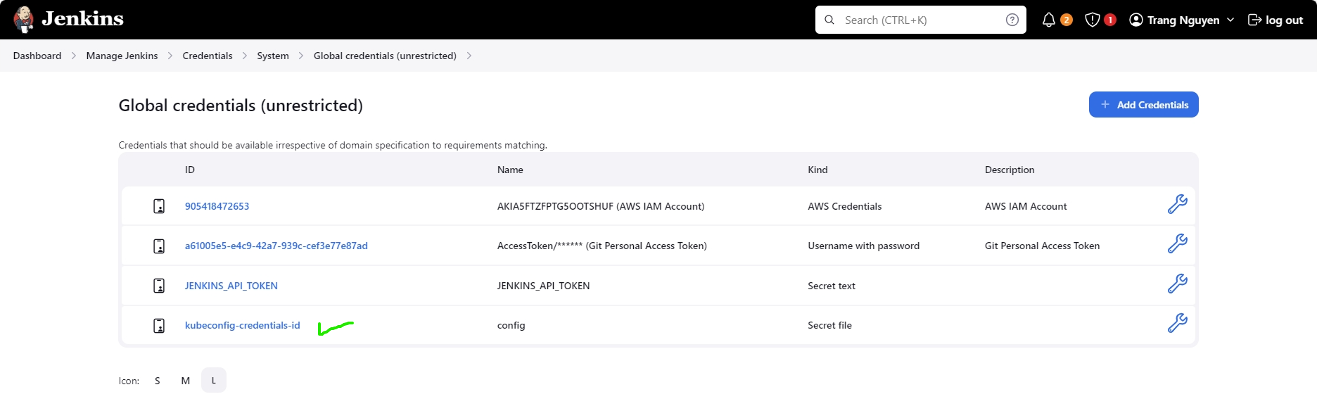

* Install Jenkins Plugins: Kubernetes CLI

## **5.3. Setup Jenkins Pipeline**

* Go to Jenkins Dashboard in the browser:
  + Dashboard -> New Item
  + Item Name – eks-pipeline
  + Select 'Pipeline' and click OK
  + Tick on 'This project is parameterized'
    - Add Parameter - String Parameter
    - Name - IMAGE_TAG
    - Default - latest
  + Under Pipeline -> Definition - pipeline script from SCM
    - SCM - git
    - Repository URL - sd3462_aws_infrastructure.git URL
    - Credentials - Select github credential
    - Branch Specifier - */main
    - Script Path: ./eks-deploy/manifest/Jenkinsfile
  + Apply & Save

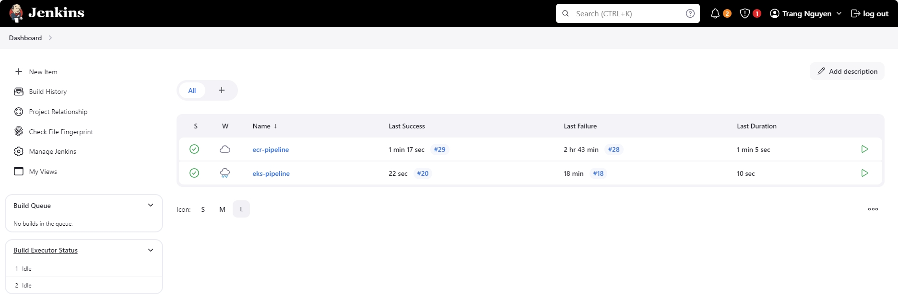

* Make commit on MSA repo.

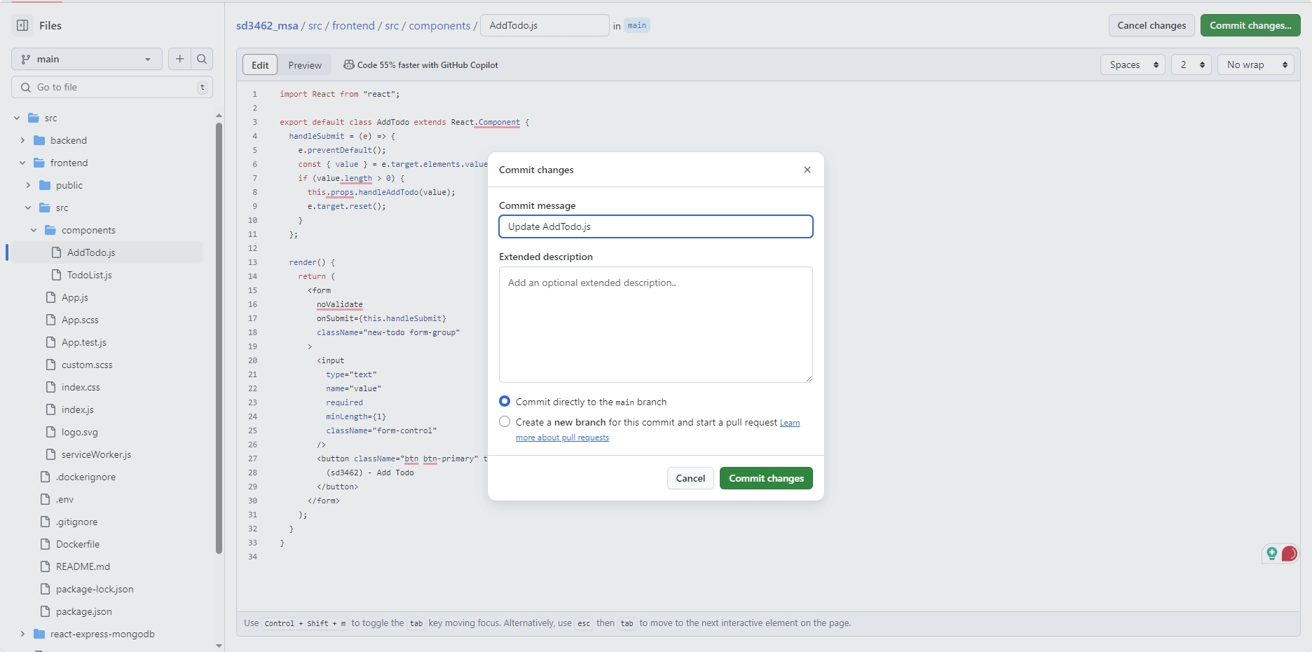

* Pipeline triggered.

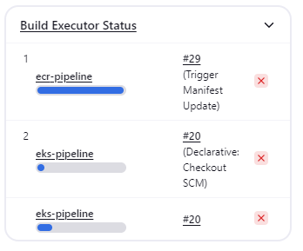

* The pipeline completed successfully.

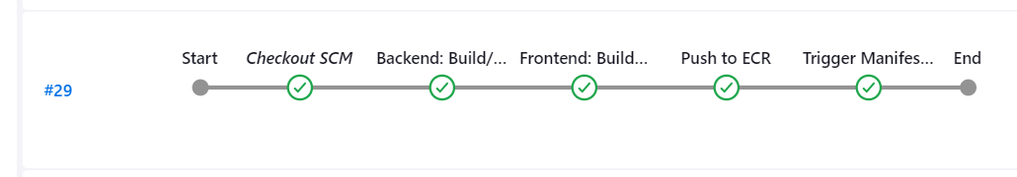

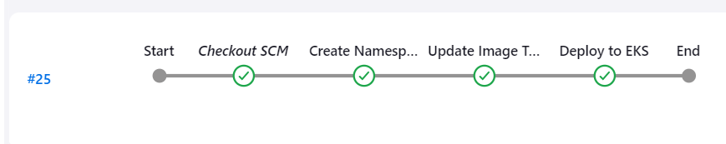

* Application deployed

1. **Monitoring with Prometheus and Grafana**